**CMSC203 Assignment 0**

Class: CMSC203

Name: Michael Shirvani

 Program: Assignment 0

Instructor: Dr. Tarek

 Summary of Description: Download and install necessary software

 Due Date: 02/07/2022

 Integrity Pledge: I pledge that I have completed the programming assignment independently.

 I have not copied the code from a student or any source.

**Complete the following five parts of Assignment 0:**

**Part1: Setup GitHub:** Provide the screen shots of your GitHub account with Assignment 0 file is uploaded here:

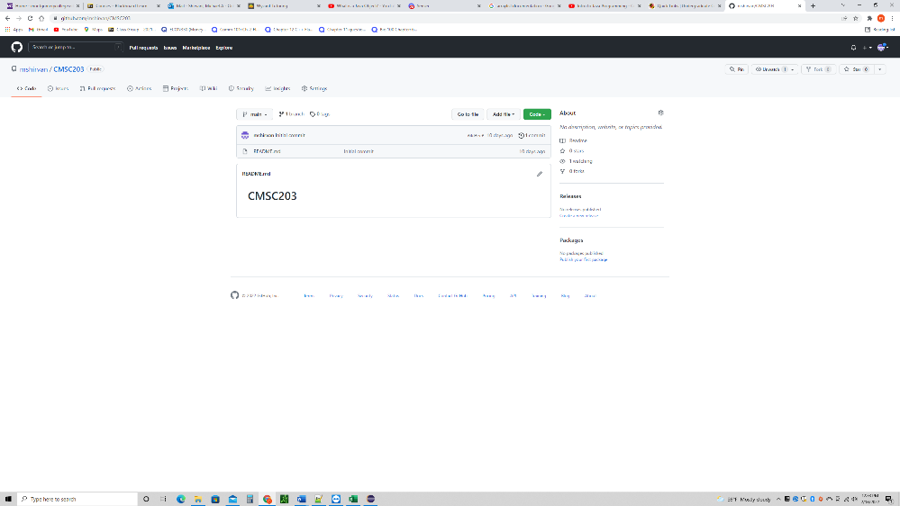

**Part 2 -Install JDK, Test java Application from Command Line**

Provide the screen shots from Step 1 and 2 here:

**Part 3 - Install Eclipse, Test Eclipse Java Application**

Provide the screen shots from Step 1 and 2 here:

**Part 4 - Install, Setup, Test Junit Program.**

Provide the screen shots showing:

* 1. Eclipse with working JUnit Test example
  2. Project screenshot
  3. Running example screenshot

**Part 5 - Install, Setup, and Test JavaFX Application.**

Provide the screen shots showing:

1. JavaFX Project screenshot
2. Running example screenshot
3. Java Source Code File

**Lessons Learned** <Provide answers to the questions listed below>**:**

Write about your Learning Experience, highlighting your lessons learned and learning experience from working on this assignment.

What have you learned?

I learned how to successfully download and install coding software. I learned how install Eclipse IDE (set up JavaFX and Junit Test inside the IDE). I also set up my student GitHub account where I will be posting all my CMSC 203 assignments.

What did you struggle with?

I struggled a lot with this assignment because I had major difficulties with setting up Eclipse. The reason behind the struggle was due to the fact that I had a custom-built PC. Since I set everything up myself, all my paths and computer files were not in the same location as a normal PC that was already built configured with everything. After long hours and many days, I learned about file systems and paths. Everything stored inside a computer has a destination that is connected to a path. I learned how to navigate, change, and create new paths for previous files and new downloaded files.

What parts of this assignment were you successful with, and what parts (if any) were you not successful with?

Downloading new software and trying to configure it with all my old files was the hardest part of this assignment. Although this struggle would only apply to students that were in the same position as myself. Once I learned how to navigate files, paths, use the terminal command prompt, I was able to successfully complete everything.

Provide any additional resources/links/videos you used to while working on this assignment.

**Check List:** <Provide answers to the column Y/N or N/A >**:**

|  |  |  |  |
| --- | --- | --- | --- |
| **#** |  | **Y/N** | **Comments** |
|  | **Assignment files:** |  |  |
|  | * FirstInitialLastName_Assignment0.docx/pdf | **Yes or No** |  |
|  | * Source java files | **Yes or No** |  |
|  | **Program compiles** | **Yes or No** |  |
|  | **Program runs with desired outputs related to a Test Plan** | **Yes or No** |  |
|  | **Documentation file: Screenshots of** |  |  |
|  | * Part1: Setup GitHub | **Yes or No** |  |
|  | * Part 2 -Install JDK, Test java Application from Command Line | **Yes or No** |  |
|  | * Part 3 - Install Eclipse, Test Eclipse Java Application | **Yes or No or N/A** |  |
|  | * Part 4 - Install, Setup, Test Junit Program | **Yes or No or N/A** |  |
|  | * Part 5 - Install, Setup, and Test JavaFX Application. | **Yes or No or N/A** |  |
|  | * Lessons Learned | **Yes or No** |  |
|  | * Checklist is completed and included in the Documentation | **Yes or No** |  |